http://www.survival-international.org/news.php?id=1268

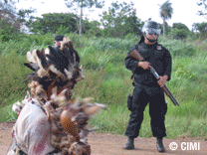
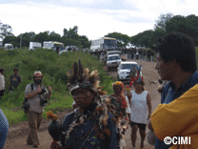
BRAZIL: Indians thrown off land - ranchers burn down houses
16 Dec 2005
Over one hundred federal police evicted the Guarani-Kaiowa Indians of رanderْ Marangatْ, Mato Grosso do Sul, from their land yesterday morning. رanderْ Marangatْ was officially recognised as the land of the Guarani-Kaiowa in March this year, but ranchers are contesting the recognition in Brazil's supreme court.
Police helicopters circled low overhead as the four hundred Indians were forced to leave the area. Brazil's President Lula put his signature to the demarcation of رanderْ Marangatْ in March after the Guarani had spent many years living on a tiny nine-hectare plot and campaigning to have their land returned to them. The signature of the president is usually the final legal step in the demarcation process.
The eviction raises the renewed spectre of starvation among the Guarani. The tribe hit the headlines earlier this year after dozens of children were found to have died of starvation due to lack of land.
The Indians are being forced into a thirty-hectare corner of رanderْ Marangatْ. Many are building shelters on the roadside as there is not enough space. The Indians had spent much of the year planting crops on part of the legally recognised 9,300 hectare area.
One of the evicted Guarani men told Survival today, ‘Helicopters flew very low over the area. Children were screaming and crying. Three people fainted and were taken to hospital. Everyone was crying and standing on the side of the road with nothing in the baking sun. We have nothing to eat. The ranchers when the police weren't there burned all our food, our clothes and documents. They burned fifteen houses. The only things we have left are the clothes on our bodies.
‘This was terrible. It was not peaceful like the Brazilian press says. This was the worst thing. Everyone is traumatised. I was there I saw it. People are saying they will commit suicide.'
Two journalists from Netherlands state television were arrested during the eviction.
For more information call Miriam Ross on (+44) (0)20 7687 8734 or email mr@survival-international.org

